Reservation Booking System
- Booking Schedule (Time difference to booking Such as: 11:00 AM to 8:00 PM)
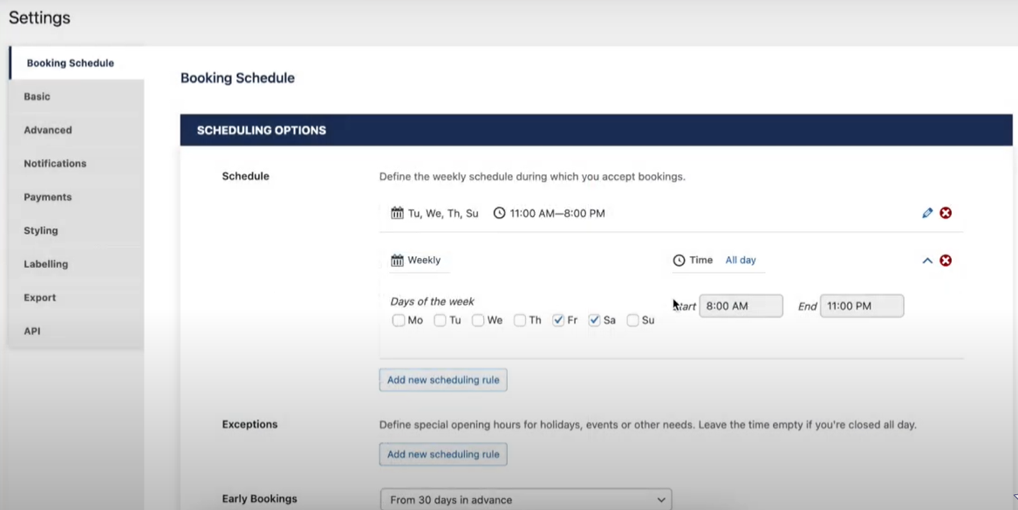
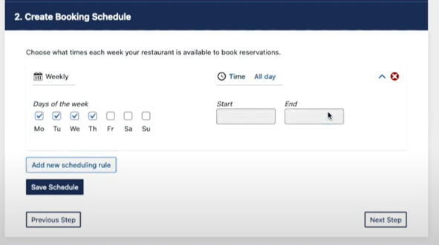
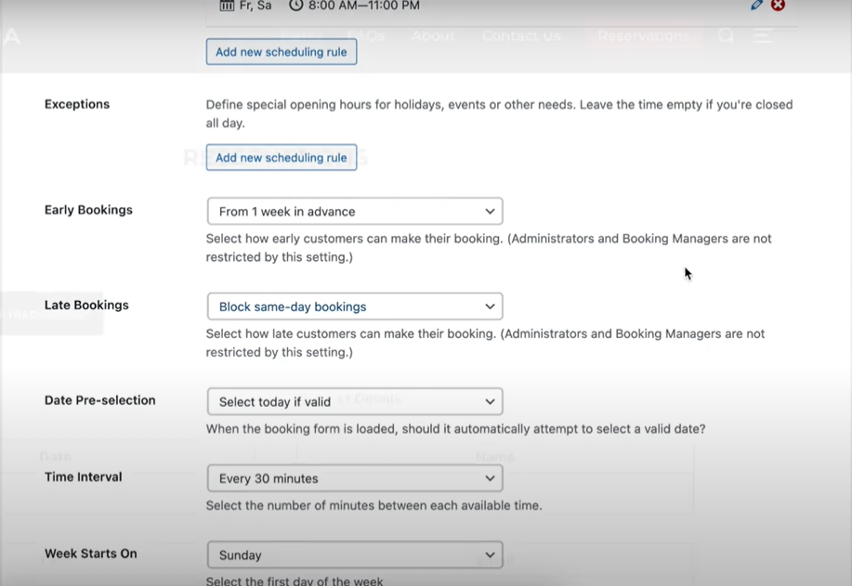
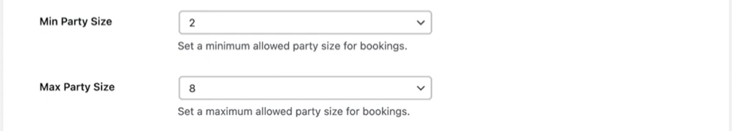

For Example: - Please below the calendar screen shot.
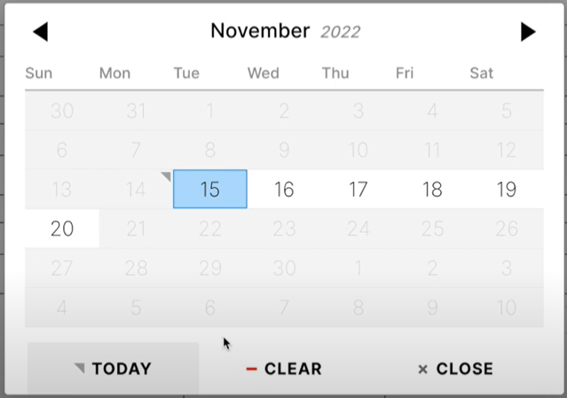
- Advanced. Set Advance details. Confirmation
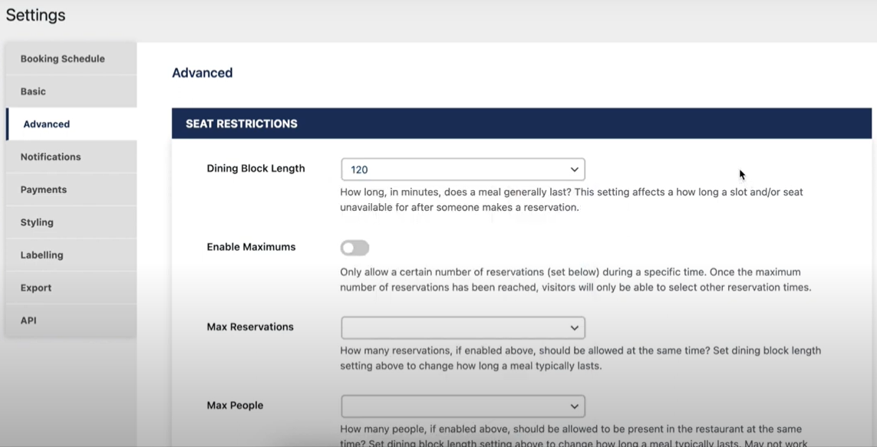

- Notification.
- Send email to customer and Restaurant VIP when reservation time.
- Send email to customer and restaurant VIP if customer makes payment. With Total Amount or Due Amount.
- If the customer arrives on the booking date, we will send a mail to the customer and restaurant VIP while changing the status of the ticket.
- After the customer pays the bill and stay, we will send an email to the customer for thanks and feedback.
- Show the feedback from admin dashboard and from customer dashboard.
- Payment History.
- Connection to payment.
- Card details save to customer.

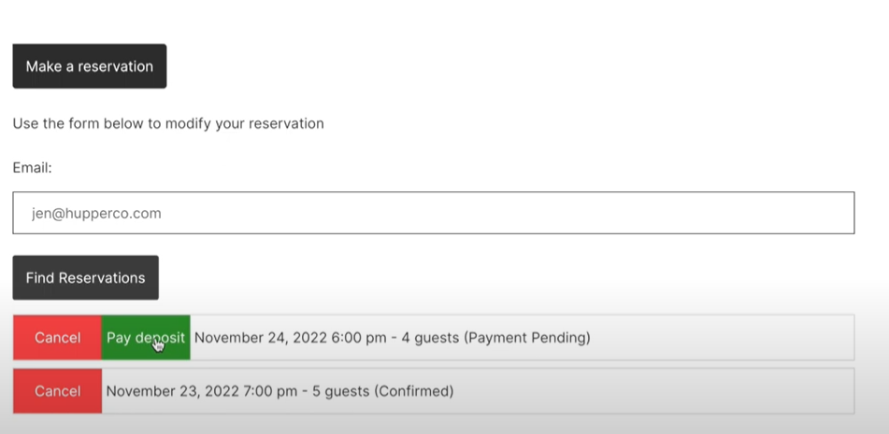
Show card details. If Card details save
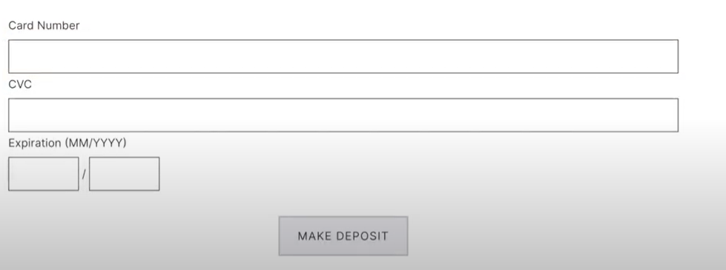
- Show the invoice details.
Type: - i) UPI, ii) Case, iii) Debit Card, iv)
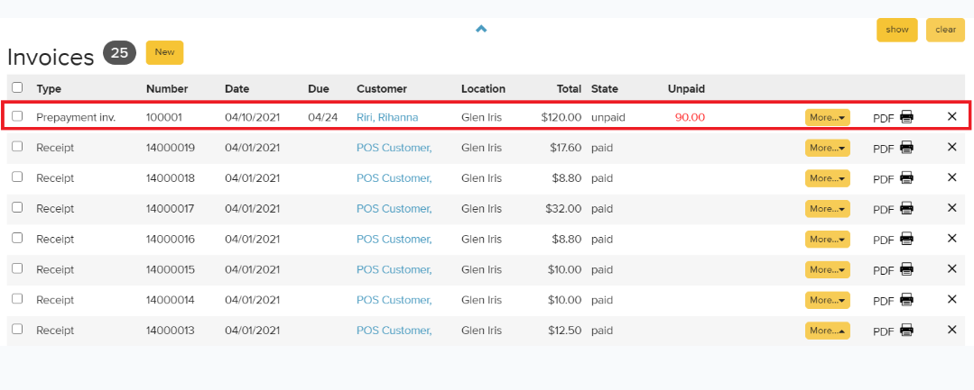
- Show payment details.
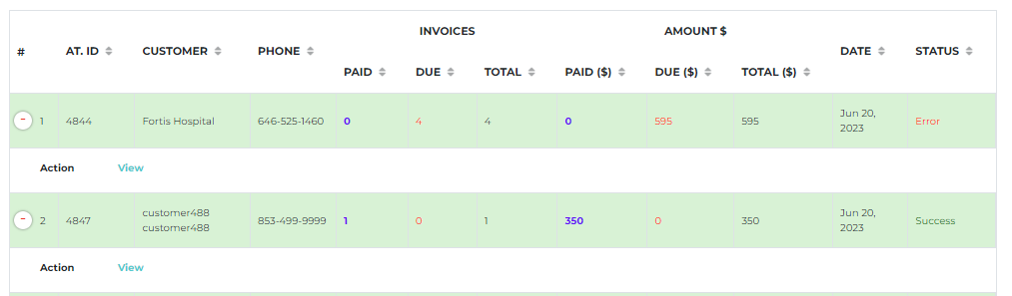
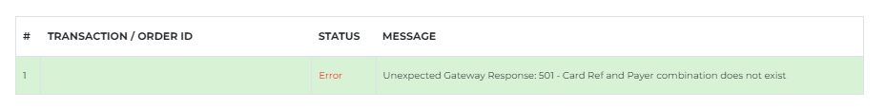
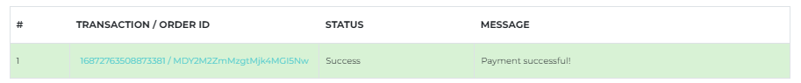

- Back End View Reservation Booking to Admin. For Confirmation.
Accountant or waiter will handle these screens. Or As per your suggestion. 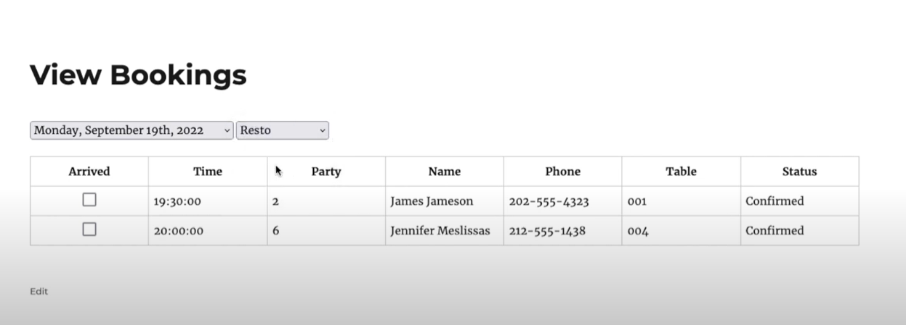
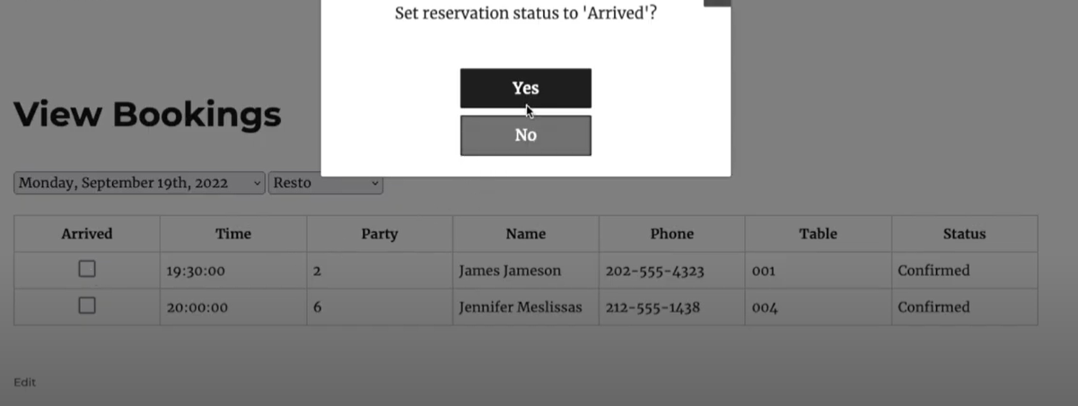
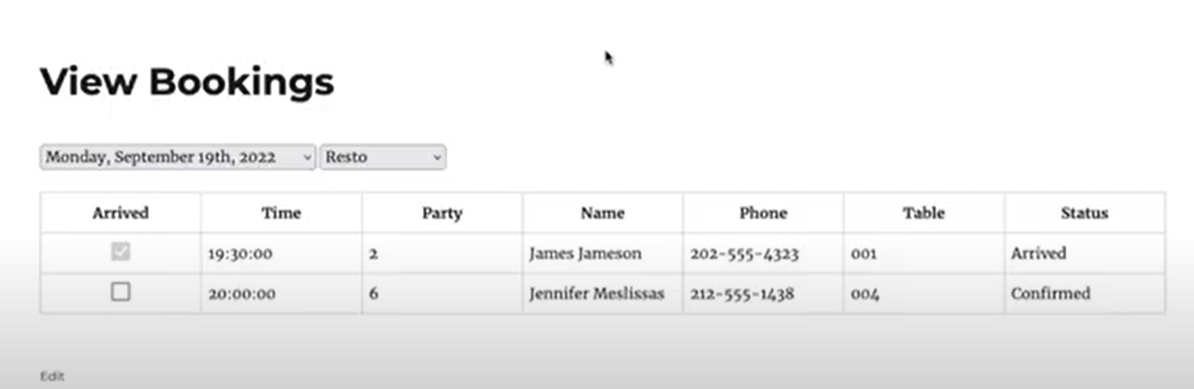

Note: - This dashboard is only show to restaurants admin. Nevertheless, restaurant admin can handle all the functionalities of this.
Party Completed then show the record from restaurant dashboard Admin.
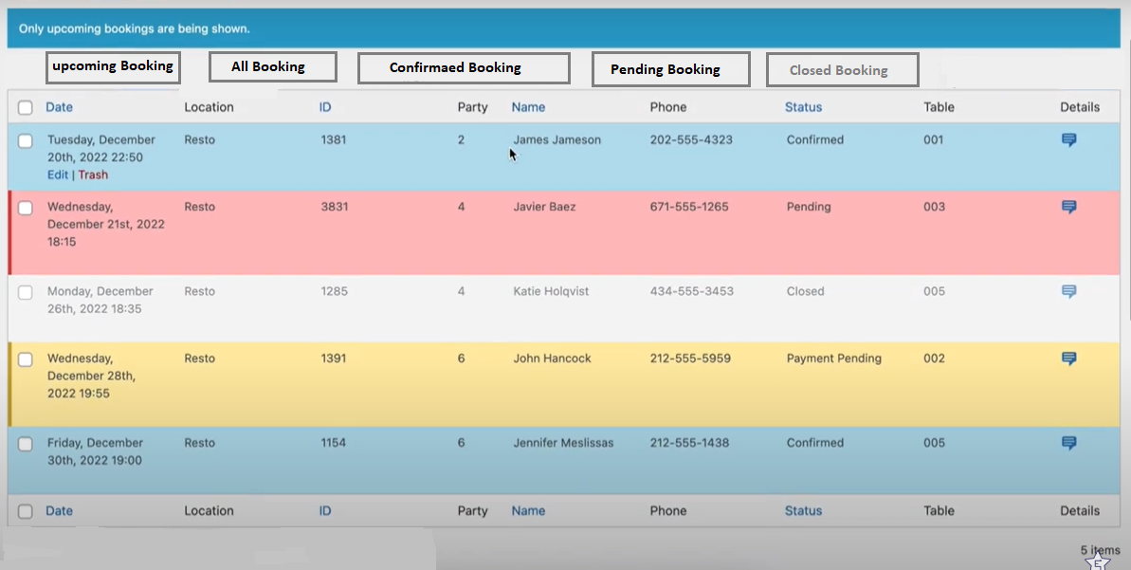

- Front End Dashboard.
Need to book the procedure through a restaurant, table/party, or have an idea.
Suggestion:
- Customers should sign up while making payment for their booking and then make payment through their debit card.
OR
- If the Customer wishes to pay the Restaurant for his/her booking in cash or UPI. Then there is no need to sign up.
- Or, both functionality implement.

Booking Reservation dashboard.
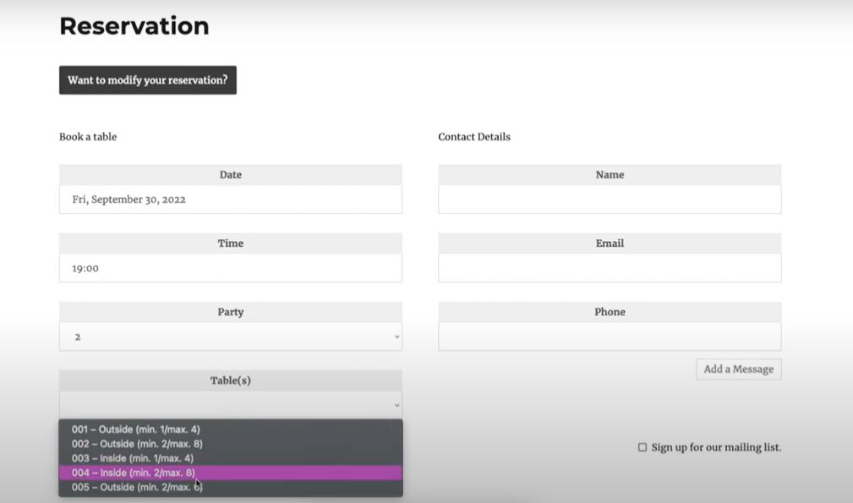

View Reservation from user dashboard.
